
lAB 7 - Learner Lab Mini-Labs
Timothy Victori

Timothy Victori
Engineering Department Arizona State University
IFT320: Managing the Cloud
Rahul Kashyap
April 21, 2025

Lab 7 - Learner Lab Mini-Labs
Mini-Lab 1: AWS CloudFormation
Figure 1
A screenshot of the DynamoDB table that was created
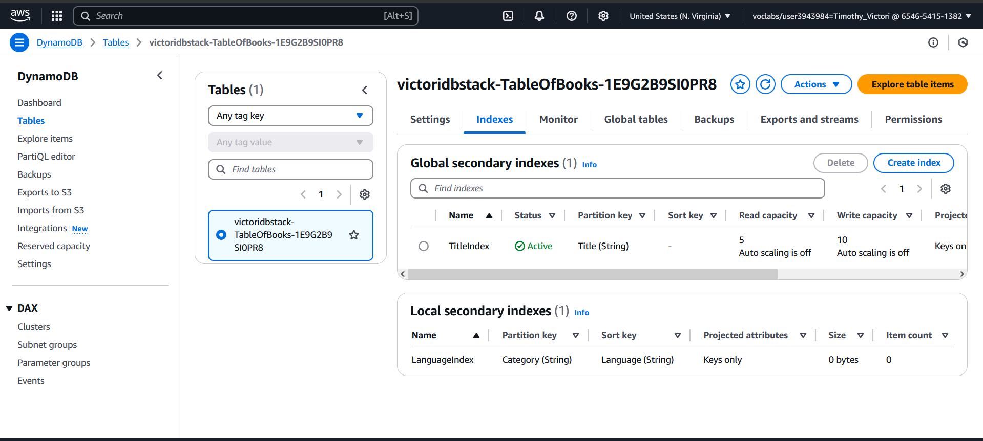

Figure 2
A screenshot of the EC2 Security Groups tab with the created Security Group
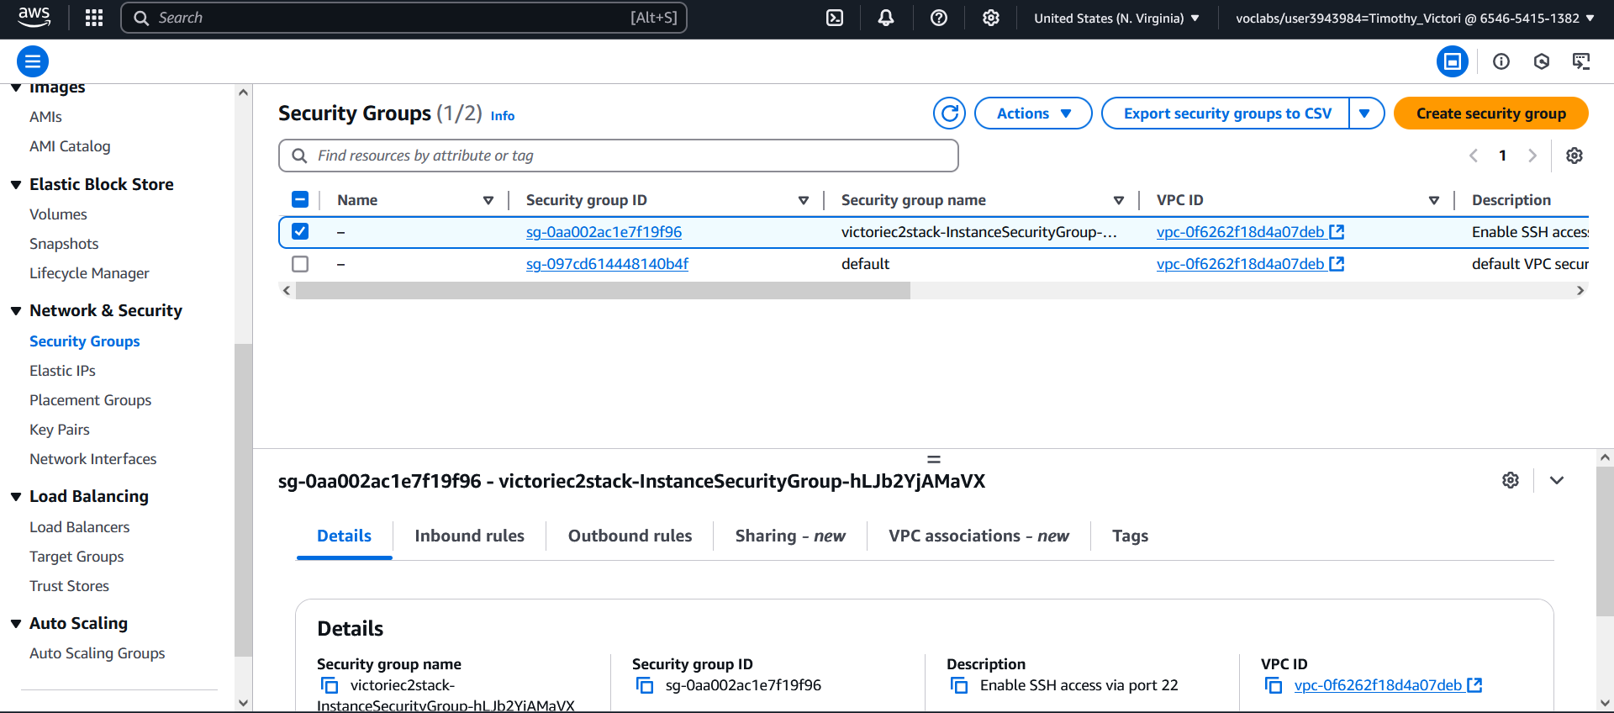

Lab 7 - Learner Lab Mini-Labs
Figure 3
A screenshot of the Deleted stacks
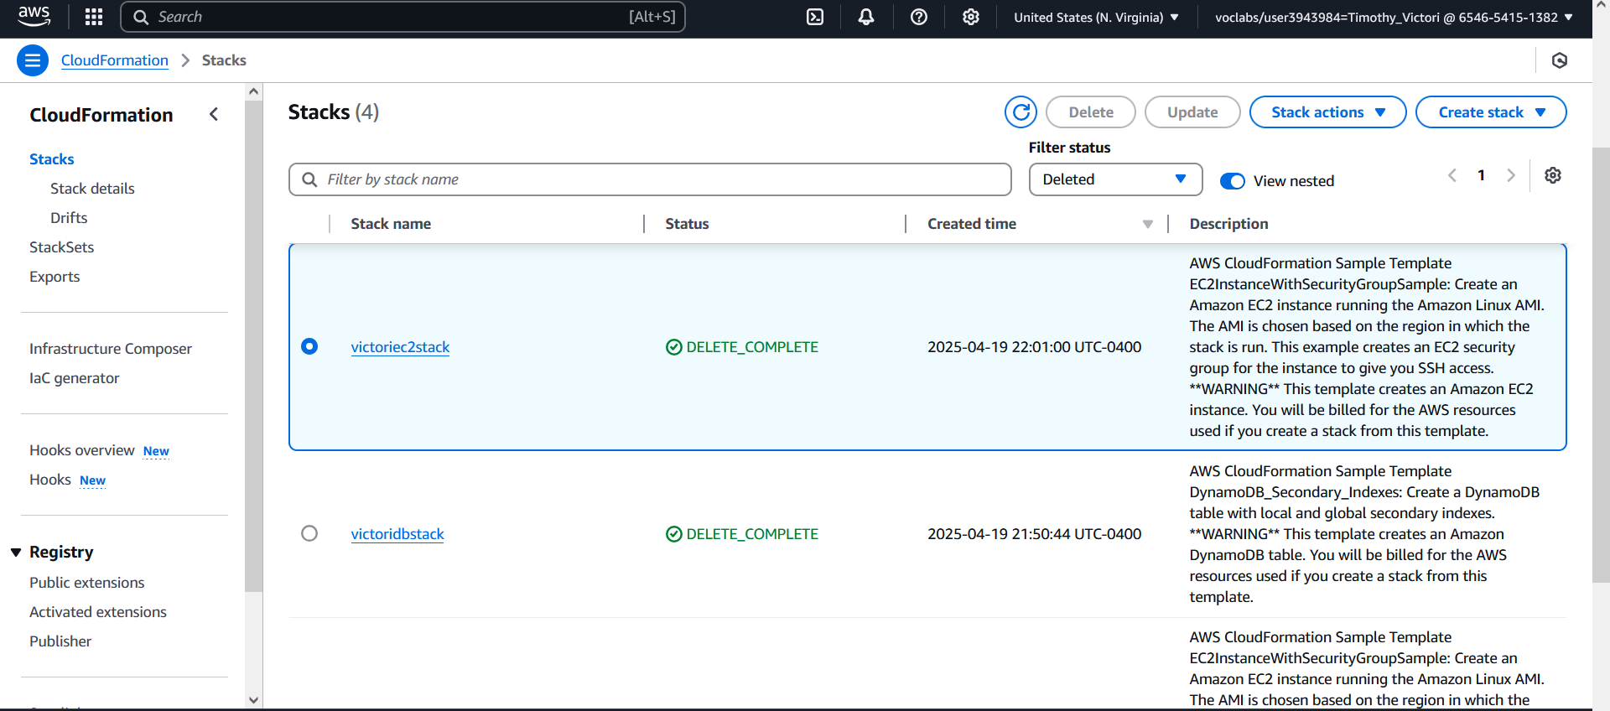

Mini-lab 2: AWS Route 53 and CloudFront
Figure 4
A screenshot of the record created using Route 53
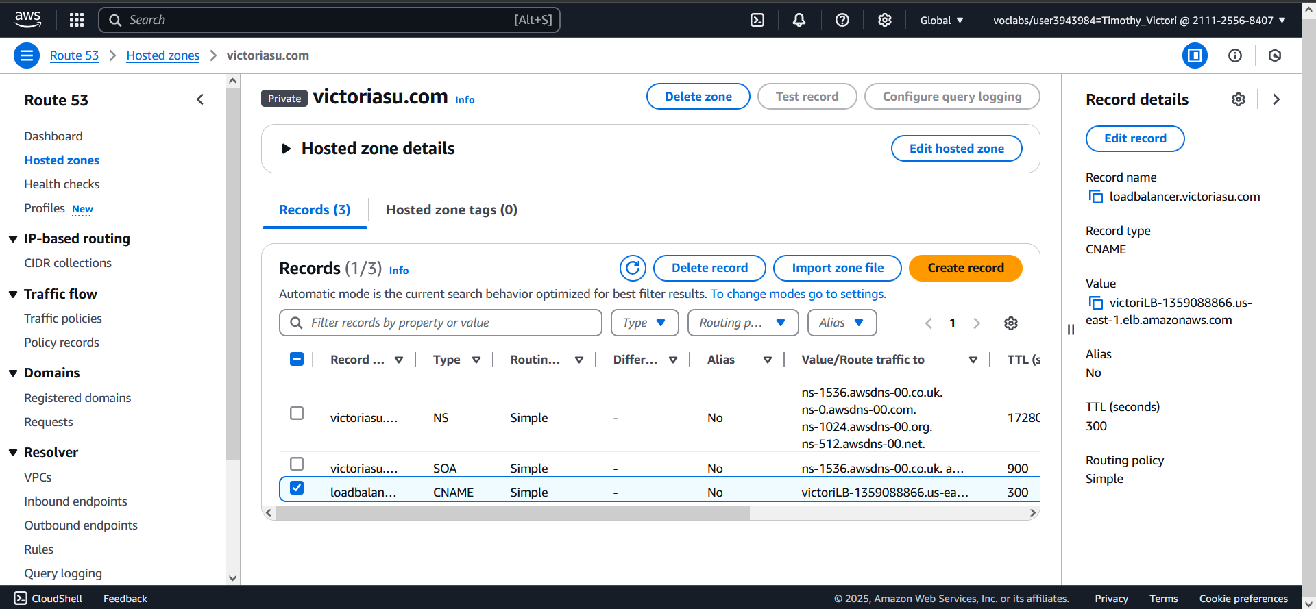
Lab 7 - Learner Lab Mini-Labs
Figure 5
Q A screenshot of the record created using Route 53
